Ball Aerospace & Technologies Corp. develops and manufactures spacecraft, advanced instruments and sensors, components, data exploitation systems and RF solutions for strategic, tactical and scientific applications.
The company is a wholly owned subsidiary of Ball Corporation (NYSE: BLL), with primary offices in Boulder and facilities in Broomfield and Westminsterin Colorado, with smaller offices in New Mexico, Ohio, Northern Virginia, Missouri, and Maryland.
They began building pointing controls for military rockets in 1956, and later won a contract to build one of NASA’s first spacecraft, the Orbiting Solar Observatory.
Over the years, the company has been responsible for numerous technological and scientific projects and continues to provide aerospace technology to NASA and related industries.

They were cited in 2014 as the 88th largest defense contractor in the world. [1]
Both parent and subsidiary headquarters are co-located in Broomfield, Colorado.

COMPANY INFORMATION AT A GLANCE
Ball Corperation Logo
http://photos.prnewswire.com/medias/switch.do?prefix=/appnb&page=/getStoryRemapDetails.do&prnid=20130108%252fLA39163LOGO&action=details
Home Page http://www.ball.com/
Aerospace page http://www.ballaerospace.com/

HOW I FOUND BALL AEROSPACE.
I was looking at a variety of satellite pages and found Mangrove Remote sensing
CLICK HERE FOR A RUN DOWN TO ANY FINDINGS ON THE SATELLITE SUBJECT.

Bloomberg business site has the following corporate information listed
EXECUTIVES
John A. Hayes,- chairman, president and chief executive officer. (Not found on Bloomberg, added after)
Mr. Robert D. Strain -President
Mrs. Ann T. Scott -Director of Investor Relations
Mr. Thomas M. Deany- Vice President of Communications
Ms. Vikki A. Schiff - Vice President of Human Resources
Mr. Frederick J. Doyle Jr.- Vice President of Defense & Intelligence Community
Dr. Mike Gazarik, -Vice President for Engineering (Former NASA, - Associate Administrator for the Space Technology Mission Directorate)
Jeff Osterkamp Vice President for Mission Assurance (former NDS - Program Management Office; Sensor and Video Technologies; and Advanced Antenna and Video Systems.)

FINANCIAL ADVISERS
Greenhill & Co., with Skadden, Arps, Slate, Meagher & Flom, Axinn, Veltrop and Harkrider, Deutsche Bank AG, London Branch and Goldman, Sachs & Co. Deutsche Bank Securities Inc., Bank of America Merrill Lynch, Goldman Sachs Bank USA, KeyBank National Association, Royal Bank of Scotland PLC , Rabobank.

AFFILIATES GOVERNMENT
DOD, NASA, NOAA,

AFFILIATES PRIVATE (NON AEROSPACE)
Rexam PLC

PREVIOUS OR CURRENT TIES WITH
NDS, Northrop Grumman, Harris Corporation, Raytheon, NASA Langley Research Center, ESA, Canadian Space Agency, American Meteorological society (AMS)

SIMILAR PRIVATE COMPAINIES (AFFILIATION NOT CHECKED)

Piedmont/Hawthorne Holdings Inc.United States,
CEF Industries, LLC, United States
Stag Arms LLC, United States
Ohio Airships, Inc..United States
Jet Parts Engineering, Inc.United States

Ball Corporation and Co employ 15,000 people worldwide and reported 2015 sales of $8 billion. ( 1 )
BallAerospace and technologies earnings were $81.8 million on sales of $810.1 million in 2015, compared to $93.6 million on sales of $934.8 million in 2014.
For the fourth quarter 2015, comparable segment operating earnings were $20.9 million on sales of $161.7 million, compared to$23.5 million on sales of $251.3 million in the fourth quarter of 2014.
Contracted backlog at the close of the year was $617 million.
Stock iformation
Further Finacials
For their latest news relaeses/source please click here or to view their history archive click here

In February 2016 The Space Foundation is taking its Space in the Community STEM education program to St. Vrain Valley Schools in February.
Former NASA astronaut Leroy Chiao, Ph.D., will share his experiences in space with students at several St. Vrain Valley Schools in Erie and Longmont, Colo., and will also join a panel discussion for a free public presentation and Star Party on Feb. 17 at Erie High School.
Space in the Community features presentations by former NASA astronauts to spark students’ interest in STEM subjects -- science, technology, engineering and math -- with the goal of inspiring students to pursue careers in those fields. ( 1 )
FOR INFORMATION ON MY FINDINGS ON STEM VISIT MY PAGE HERE

In February 2016 all five of the complex instruments were integrated on the Joint Polar Satellite System-1 (JPSS-1) satellite for NOAA's next polar-orbiting weather satellite mission
The Advanced Technology Microwave Sounder (ATMS) was the final instrument to be integrated onto the JPSS-1 satellite, scheduled to launch in early 2017.
ATMS provide the same high quality observations currently available from the NOAA/NASA Suomi NPP satellite and is necessary to retrieve profiles of atmospheric temperature and moisture for civilian operational weather forecasting as well as continuity of these measurements for climate monitoring purposes. For accusations towards NOAA for hiding Global Warming Data please click here and then another main stream outlet saying the opposite here and then the article from NOAA proving that they shouldnt be trusted with such a Task (if you ask me, but Click here for to get a run down on Climate change or click here for a run down on NOAA)
Ball built Suomi National Polar-orbiting Partnership (Suomi NPP) satellite, JPSS-1 hosts a total of five instruments.
In addition to the ATMS, built by Northrop Grumman, instruments include the Cross-track Infrared Sounder (Harris Corporation), the Visible Infrared Imaging Radiometer Suite (Raytheon), the Clouds and the Earth's Radiant Energy System (NASA Langley Research Center) and Ball's Ozone Mapping and Profiler Suite-Nadir (OMPS).
Polar weather satellites contribute 85% of the data that goes into numerical weather prediction models.
NOAA's JPSS-1 satellite will be responsible for delivering the primary data contribution from the afternoon orbit. Launch of the instrument-loaded orbiter will continue accurate/reliable weather forecasting and provide severe storm warnings days in advance that protect lives and property across nation.
Under contract to NASA's Goddard Space Flight Center in Greenbelt, Maryland, Ball Aerospace is responsible for designing and building the JPSS-1 satellite, building the OMPS-Nadir instrument, integrating all instruments, and performing satellite-level testing and launch support.
NOAA provides the funding, requirements, operations and science for JPSS and teams with NASA, which procures the flight segment and portions of the ground segment. ( 1 )

On February 4th 2016 The 18th and final primary mirror segment is installed on what will be the biggest and most powerful space telescope ever launched. The final mirror installation Wednesday at NASA’s Goddard Space Flight Center in Greenbelt, Maryland marks an important milestone in the assembly of the agency’s James Webb Space Telescope.

Ball is the principal subcontractor to Northrop Grumman for the optical technology and optical system design. The installation of the mirrors onto the telescope structure is performed by Harris Corporation, a subcontractor to Northrop Grumman. Harris Corporation leads integration and testing for the telescope.( 1 )

On January 4th 2016 they promoted Dr. Mike Gazarik, Technology Director, to the position of Vice President for Engineering and named Jeff Osterkamp Vice President for Mission Assurance. Gazarik joined Ball in March of 2015 from NASA where he was the Associate Administrator for the Space Technology Mission Directorate at NASA headquarters. In transitioning from the role as VP for Engineering to VP of Mission Assurance, Osterkamp replaces Sherri Fike who retired in December. Osterkamp has more than 30 years of experience at Ball Aerospace. His previous roles include executive leadership of the company's component technologies business area; the National Defense strategic business unit; the Program Management Office; Sensor and Video Technologies; and Advanced Antenna and Video Systems.

The James Webb Space Telescope is the scientific successor to NASA's Hubble Space Telescope. It will be the most powerful space telescope ever built. Webb will study many phases in the history of our universe, including the formation of solar systems capable of supporting life on planets similar to Earth, as well as the evolution of our own solar system. It’s targeted to launch from French Guiana aboard an Ariane 5 rocket in 2018.

Webb is an international project led by NASA with its partners, ESA (European Space Agency) and the Canadian Space Agency. ( 1 )

Ball Aerospace acquired Wavefront Technologies In January 2016.
Wavefront Technologies, located in Annapolis Junction, Maryland, provides systems and network engineering, software development software and analytical services for cyber and mission-focused programs to the U.S. government and commercial industry.
http://www.prnewswire.com/news-releases/ball-aerospace-acquires-wavefront-technologies-300212194.html

In January 2016 Ball Aerospace & Technologies Corp. kicked off 2016 celebrating 60 years in the aerospace industry at the 96th annual American Meteorological Society (AMS) annual meeting.
The 96th meeting of the AMS drew more than 3,000 scientists, researchers, educators, students, and other professionals from across the weather, water and climate community at the Ernest N. Morial Convention Center, New Orleans, Louisiana.
Ball LIDAR research scientist, Sara Tucker, made one of several presenters during the session, “Advances in Satellite Observations and Earth Science and Observing Technologies.” Tucker will detail Ball’s work on the Green-OWAL (GrOAWL) Airborne Demonstrator for the ATHENA-OAWL mission concept. ( 1 )

In December 2015 NASA awarded a letter contract to Ball Aerospace & Technologies Corp. to build the Operational Land Imager-2 instrument for the Landsat 9 project.
The estimated value of this cost-plus award-fee letter contract is $19.3 million with a period of performance from Dec. 31, 2015 through March 31, 2021.
Ball Aerospace will build a second Operational Land Imager (OLI) for the Landsat 9 project.
The OLI satisfies stringent image quality performance standards for radiometric, spectral, spatial, uniformity, and calibration that are critical for producing data that meets the users’ needs in analyzing deforestation, agricultural yield estimates, spread of pest infestations, urbanization, water resources, and many other operational and research applications. ( 1 )

In early 2015 an announcement was made of a possible acquisition of Rexam which has affiliation with the Rothschilds. This is said to be completed by mid 2016.
Other Acquisitions include Reynolds Metals in 1998, Schmalbach-Lubeca in 2002, U.S. Can in 2006 and the AB InBev plants acquisition in 2009 ( 1 )

CURRENT PROJECTS

- The Orbital Express[2] autonomous satellite servicing mission
- The Kepler Space Observatory[3] satellite to search for habitable planets
- The James Webb Space Telescope (JWST) to study the formation of the earliest stars in the universe.
- The Wide-field Infrared Survey Explorer (WISE) Program, which, over a seven-month mission in a polar orbit will map the entire sky in multiple mid-far infrared wavelengths. This crucial mission may find close and cool objects to our sun never before detected. It will also act as a predecessor to the JWST Program.
- The WorldView-2 earth observation satellite.[4]
- The WorldView-3 [5] earth observation satellite.
- The Opticks[6] remote sensing data visualization application.
- The Sentinel space observatory, a satellite in Venusian orbit which will scout for hazardous asteroids.
- The Arizona State University (ASU), thermal emission imaging system (E-THEMIS) for Nasa's mission to study the Jupiter moon, Europa.[7]

HISTORICAL
- -DigitalGlobe's remote sensing spacecraft: QuickBird (with Orbital Sciences Corporation), WorldView-1, and WorldView-2

- -The instrumentation for the Spitzer Space Telescope. Ball Aerospace developed the Cryogenic Telescope Assembly (CTA) and two of the three science instruments: the Infrared Spectrograph (IRS) and the Multiband Imaging Photometer (MIPS).

- -Instrument packages for the Hubble Telescope, including the Advanced Camera for Surveys (ACS), the Cosmic Origins Spectrograph (COS) and the Wide Field Camera 3 (WFC3), all which were installed on the observatory during the Space Shuttle mission STS-125 in 2009.

- After the servicing mission was completed, all of Hubble's scientific instruments are of Ball Aerospace manufacture.

- -Ball also built the Corrective Optics Space Telescope Axial Replacement (COSTAR), which corrected an early defect in the Hubble's main mirror, the Near Infrared Camera and Multi-Object Spectrometer (NICMOS), and the Space Telescope Imaging Spectrograph (STIS) instruments.

- -AEROS[8]

- -CALIPSO, a joint NASA and CNES environmental spacecraft

- -CloudSat, a NASA Earth observation spacecraft

- -Deep Impact spacecraft. Ball Aerospace designed and built the spacecraft and all of its instrument packages for NASA.

- -Star trackers for NASA's Space Shuttle program

- -The Mars Reconnaissance Orbiter (MRO) HiRISE camera

- -Joint Strike Fighter (JSF) conformal antennas

- -High-Gain Antenna Gimbal (HGAG) and the Panoramic-camera Mast Assembly (PMA) for the Mars Exploration Rover

- -Orbiting Solar Observatory (OSO)

- -Infrared Astronomical Satellite (IRAS).

- -Ball Aerospace developed and built the cryogenically cooled telescope, dewar and sunshade
- The Mast Mounted Sight for the OH-58D Kiowa helicopter

- SBUV/2 Solar Backscatter Ultraviolet Radiometer

As you can probably see this is no small company, They have worked on some of the top projects in the industry for some big players.
Where did they come from? How did they get into the industry?
When looking into subjects like this i think it is important to understand the company and their origins.
I Thought I'd start by having a good look at the Ball official website.
As soon as i started hovering the mouse around I got the feeling there was a lot more to find.
The first thing i noticed in huge font was the word "SUSTAINABILITY"
You may know another organization that uses this word often and is in fact saying like it is going out of fashion, The United Nations.
I know this sound like a good thing but i suggest you check out my UN AGENDA page.
The other thing that i notice was , and i know this was a huge coincidence but the 66.06 (666) in the bottom right had corner.
I also find it interesting that a Company in the Aerospace industry would be in "packaging". I hadn't looked much at their history as yet so it didn't make a lot of sense. After a bit of reading it did but I would just like to point out that they package EVERYTHING, Our food and drink products included. And they have been buying up every competitor in the industry for years.
""Ball provides metal packaging solutions for everything from beer and energy drinks to asparagus and sauerkraut to paint and insecticide"
All Aluminium and they sell basically world wide South America, Asia , Europe and North America. Please keep this in mind when I'm explaining the UN .
I also noticed the "Offer for Rexam" Tab.
Rexam is also a "sustainable" company and is the global leading beverage can manufacturer. On page 2 of the Chairman's Letter and announcement document, found on Rexams "Ball Corporation offer" tab dated February 6th 2015 states that enquiries can be made to the following
Tulchan Communications (Media Adviser to
Rexam)
+44 (0)20 7353 4200
Andrew Grant
Martin Robinson
Rothschild (Financial Adviser to Rexam) +44 (0) 20 7280 5000
Robert Leitão
Ravi Gupta
Yuri Shakhmin
Barclays (Financial Adviser to Rexam) +44 (0)20 7623 2323
Richard Taylor
Mark Astaire
Andrew Owens
So the Rothschilds are linked to Rexam. If you are not familiar with the family name please look into it further or read my findings HERE

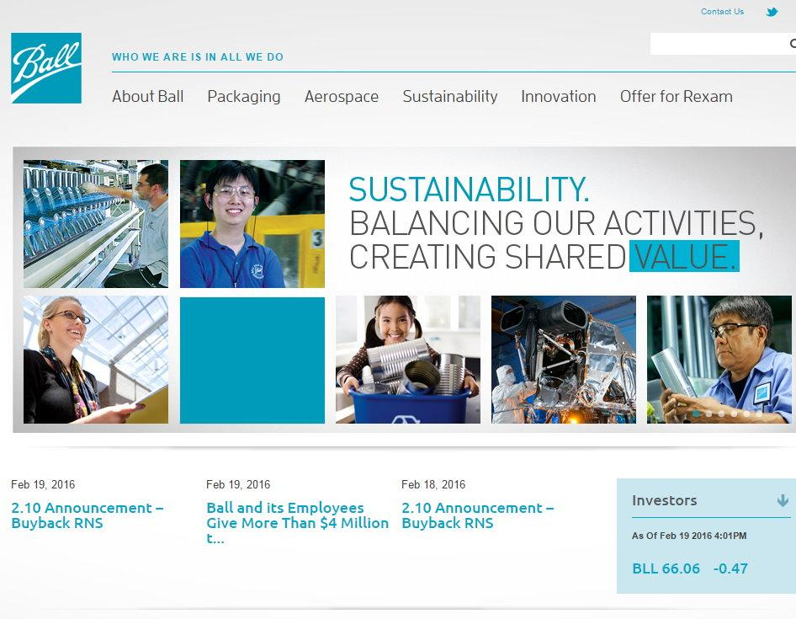

On the Home page I saw this image.

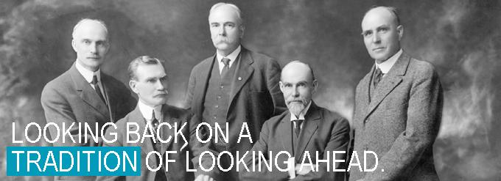

Firstly, 2 of them looked very familiar. I think I recognize the guy in the middle and the guy on the far right.

Secondly the caption "looking back / looking ahead" found a few interesting sites when I googled it.
One was to MMSA or Maine Mathematics and Science Alliance which had STEM all over their site, again please Click here for my findings on STEM. Maine is a state that is divided into 24 Masonic districts ( 1 ) containing 185 Masonic Lodges ( 1 ) and a Masonic Collage ( 1 ). If your unfamiliar with Freemasonry click here
One was to a document for FIG or the International Federation of Surveyors who have workshops with the U.N ( 1 ).
Another was to a document from USC talking about "the end of shared governance" based around education and around Universities and another to do with education and Association for Authentic, Experiential, & Evidenced Based Learning (AAEEBL)
And another to The Bipartisan Policy Center talking about the DODD-FRANK ACT which is essentially a way for major banks to be closed down.
Keep in mind that affiliated organizations tend to use the same language, Just like "Sustainability"

I clicked on the "Our History" tab and i was certain i recognize the 2 guys but i still don't know where from.
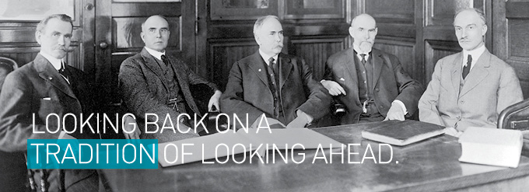

"Five brothers founded Ball in 1880 with a $200 loan from their Uncle George. In the beginning, they made wood-jacketed tin cans for products like paint and kerosene, but soon expanded their offerings to glass- and tin-jacketed containers. In 1884, the brothers began making glass home-canning jars, the product that established Ball as a household name. The brothers—Edmund, Frank, George, Lucius and William—moved the company from Buffalo, New York, to Muncie, Indiana, in 1887 to take advantage of abundant natural gas reserves essential to making glass. Ball grew rapidly in the ensuing decade and has been in more than 45 businesses since its founding."
I know its the land of the free and the land of opportunity but how did these 5 guys go from $200 making wood-jacketed tin cans to sales of $8 billion last year. ( 1 ) and end up being in the aerospace industry?
The link provide on the site didn't provide a lot of information so i googled "Ball Brothers". I could only find one Wikipedia link which provided enough information to make a start. Lets start at the beginning

Parents Lucius and Maria Polly Ball raised the 5 brothers in eastern Ohio and in upstate New York.[1]
Frank and Edmund Ball, after borrowing $200 from their Uncle George Harvey Ball, start the Wooden Jacketed Can Company in Buffalo, New York. in 1880 and started manufacturing and selling wood-jacketed tin containers to hold paint, varnishes and kerosene.

Their product was so successful they expanded their line. Soon, the brothers had refined their original product to tin-jacketed, glass-lined containers. In 1984 they renamed the company "Ball Brothers Glass Manufacturing Company" and began manufacturing yet another new product – the home canning jar. They were the first factory to produce canning jars which are now a collectors item ( 1 ) and sometimes know as "Ball jars"due to their prolific manufacture.
Taking advantage of the Indiana Gas Boom of the 1880s, as gas is highly efficient in glass making they began construction on a new factory in Muncie, Indiana in 1887 .
Now Muncie is an interesting place on its own and has a history of Freemasonry. To see my findings on Freemasonry click here
Muncie has a uncanny ability to predict US presidential elections . Muncie has gone for every winning president bar JFK for over 60 years and the polls taken prior to the vote can be used to predict the result and in most cases the voting percentages were nearly identical to the national result (2 cases were identical) and is referred to as "the lawnmower vote". ( 1 , 2 , 3 , 4 , 5 , 6 ). This would tend to agree with the statement by many that presidents are "selected not elected"
In 1929 A team of sociologists led by Robert and Helen Lynd, who were only the first to conduct a series of studies in Muncie, lightly disguised as "Middletown".
The Lynds were invested and appended to masonic lodges and one of their topics of study was for fraternal orders in small town america in which they reported that "the great days of the lodges have vanished." ( 1 , 2 pg 202, 3 pg 111 ) and can be seen in the book Middletown - A Study In American Culture
The second study they conducted in 1937 "Middletown in Transition : A Study in Cultural Conflicts," is sharply political and made predictions on the possibility of a future American dictatorship due to consumerism that never came to pass. ( 1 , 2 ) AS OF YET.......I would argue we are already there but See the NEW WORLD ORDER page.
Robert Lynd also attended many known masonic schools and institutions including Princeton University earning an A.B. degree, New School for Social Research, Union Theological Seminar receiving a Degree of Bachelor of Divinity , Columbia University receiving a PhD in sociology in 1931 using an abridged version of "Middletown" as his dissertation.
The FBI have files claiming him to be a "leftist" and a communist ( 1 ), and he played a central role in helping Lazarsfeld emigrate to the United States. Lazarsfeld and his by then ex-wife fled the Austrofascist regime before Adolf Hitler’s takeover, and Zeisel followed shortly thereafter. All three ended up as professors in the United States: Lazarsfeld at Columbia, Lazarsfeld-Jahoda at New York University and Zeisel at the University of Chicago ( 1 )
The studies were commissioned by the Rockefeller Institute of Social and Religious Research ( 1 , 2 ) funded by Russell Sage Foundation, the Ford Foundation, the Carnegie Corporation, and actually two Rockefeller philanthropies, the Laura Spelman Rockefeller Memorial and the Rockefeller Foundation. ( 1 ). The organization's ultimate goal was to unite all the protestant churches in the nation, through the network of common social service. The Lynds were originally commissioned by the Institute for Social and Religious Research to strictly study religious practices but they went over their assignment on their own accord ( 1 )
Now while the Rockefellers are not known masons it is clear that they are affiliated with organizations and families who are and finance their activities.
To see my findings on the Rockefeller Family Click Here

On February 7, 1888, a Certificate of Incorporation was filed for the Ball Glass Works of Muncie. On February 18, fires were started in the furnace, on February 26, the blowers began to arrive and on March 1, the first products were made. The first products made in Muncie were coal oil containers and lamp chimneys, not fruit jars.
William and George remained in Buffalo to operate the factory in New York.
The company continued to prosper.
After receiving his doctor of medicine degree from the University of Buffalo in 1889 The eldest brother, Lucius moved to Muncie in 1894.
and the Ball family made a number of philanthropic investments in the community.

On July 25 1917 the brothers bought the Indiana Normal Institute from foreclosure. It had started in 1876 as a private called the Eastern Indiana Normal School. The entire school, including classrooms, library, and president's residence were housed in what is today's Frank A. Bracken Administration Building. The one-building school had a peak enrollment of 256 and charged $10 for a year's tuition. It operated until the spring of 1901, when it was closed by its president, F.A.Z. Kumler, due to lack of funding. A year later, in the autumn of 1902, the school reopened as Palmer University for the next three years when Francis Palmer, a retired Indiana banker, gave the school a $100,000 endowment.

Between 1905 and 1917, the school dropped the Palmer name and operated as the Indiana Normal College. It had two divisions, the Normal School for educating teachers and the College of Applied Sciences. The school had an average enrollment of about 200 students. Due to diminishing enrollment and lack of funding, school president Francis Ingler closed Indiana Normal College at the end of the 1906–1907 school year. Between 1907 and 1912, the campus sat unused. In 1912, a group of local investors led by Michael Kelly reopened the school as the Indiana Normal Institute. To pay for updated materials and refurbishing the once-abandoned Administration Building, the school operated under a mortgage from the Muncie Trust Company. Although the school had its largest student body with a peak enrollment of 806, officials could not maintain mortgage payments, and the school was forced to close once again in June 1917 when the Muncie Trust Company initiated foreclosure proceedings.

The Company name was again changed to Ball Brothers Company in 1922.

in 1920 construction began on the Muncie Masonic temple and was finished in 1926

Ball brothers offered up a $150,000 donation in order to add an auditorium to the structure. Frank C. Ball, in particular, stated that his hope was to provide a place for high-level entertainments to be held in Muncie and that he saw the construction of the new Masonic temple as a perfect place.[4]

"Several years ago when our brothers Will and Ed were with us we talked several times of providing an auditorium for the benefit of the citizens of Muncie, where recitals, lectures, concerts, and entertainments of various kinds, of a high order, could be given. The control and management of such an auditorium was a difficult one to decide, and it was not decided until the time when the Masonic Order was planning to build a new temple. Ed, who was deeply interested in Masonry (he being Thirty-third Degree Mason), suggested that we build an auditorium in connection with the temple and place it under control of the Masonic Order."[5]

In 1929 they founded the Ball Memorial Hospital which is affiliated with the Indiana School of Medicine.

By 1937, the value of the Ball Brothers Company was estimated at nearly $7 million.

Ball forms the Ball Brothers Research Corporation. Known today as Ball Aerospace & Technologies Corp., the corporation produces space systems engineering products, telecommunications technology, and electro-optics and cryogenics materials for government and commercial customers. ( 1 )

Glass production in Muncie ceased in 1962 but continued at other Ball plants. Ball went public on July 13, 1972, and its stock was traded over the counter. On December 17, 1973, the stock was admitted for trading on the New York Stock Exchange under the symbol BLL. Stock began trading at $26 per share.

Company headquarters moved from Muncie to Broomfield, Colorado in 1998. Ball no longer produces the glass fruit jar; the license to produce the jar now is owned by Jarden Home Brands. Jarden produces all lids for all brands of fruit jars at its Muncie plant. Jars are made by a variety of glass producers.

https://books.google.com.au/books?id=jyOZw1KjulEC&pg=PA38&lpg=PA38&dq=Wooden+Jacketed+Can+Company&source=bl&ots=rTcSBDF-Rn&sig=fgrluib-F79sSxMJt8m0BQjwuCc&hl=en&sa=X&ved=0ahUKEwihppir7JDLAhVJoJQKHbYuCn0Q6AEIOTAF#v=onepage&q=Wooden%20Jacketed%20Can%20Company&f=false

and the Ball family made a number of philanthropic investments in the community.. Since then, the company has subsequently expanded and diversified the enterprise.
In the following decades, the brothers funded in whole or in part Ball State University, Ball Memorial Hospital, the local YMCA, and the Minnetrista cultural center and golf course.[3] The Ball brothers did not forget New York or the help of their uncle, George Harvey Ball, who shared the Ball family dedication to higher education and who founded Keuka College. The Ball brothers provided funds and land for Keuka College in New York (see below).

http://www.ball.com/timeline/

1st Image sources
Minnetriista
William Hudson Ball
The great Depression - Ball State University
New articles in Communication Information
Bottle Pickers
The Balll Brother lament
Ball Brothers Turn of the century
Frank L Ball and the Marcy brothers 1948
These men not only created
A legacy etched in glass

The Ball Brothers
https://en.wikipedia.org/wiki/Ball_Brothers

https://www.google.com.au/search?q=ball+brothers&biw=1821&bih=870&source=lnms&tbm=isch&sa=X&ved=0ahUKEwih0tHhuofLAhUEXqYKHVH3BRwQ_AUIBygC&dpr=0.75#imgrc=KUkzTe5IJy_SYM%3A

The Ball brothers were responsible for founding the Ball Corporation and Ball State University as well as may other projects in their community of Muncie, Indiana.

Their parents, Lucius Styles Ball (1814-1878) and Maria Polly Bingham Ball (1822-1892) had six sons and two daughters: Lucina Amelia, Lucius Lorenzo, William Charles, Edmund Burke, Frank Clayton, Mary Frances, George Alexander, and Clinton Harvey, who died in infancy.

remember the K-12 school funding provided by the ball brothers as it links to the STEM programs

The brothers[edit]
- Lucius Lorenzo Ball (1850-1932) The eldest Ball brother was a resident of Muncie for 30 years. He was born in Greensburg, Ohio on March 29. Married to Sarah Rogers and received his degree from theUniversity of Buffalo. As a doctor, he was very well known within the community and was a leading practitioner in medicine for the city.[4]
- William Charles Ball (1852-1921) William was born in Trumbull County, Ohio. When the Ball Brothers moved to Indiana, he remained in Buffalo, New York to close out affairs. He finally moved to Muncie in 1897. He married Emma Wood Ball. William was the secretary for the Ball Company. Like his brothers, he was heavily involved in the political world of Muncie.[5]
- Edmund Burke Ball (1855-1925) Edmund Burke was also born in Ohio and traveled to Muncie with his wife, Bertha. Edmund served as treasurer of the corporation and was one of the original co-founders with his brother, Frank.[6]
- Frank Clayton Ball (1857-1943) Frank Clayton was the President of the Ball Brothers Corporation. He was born in Greensburg, Ohio. Like the other Ball brothers, Frank took an interest in the public affairs of the community in Muncie. Frank was also president of the Muncie YMCA.[7]
- George Alexander Ball (1862-1955) George Alexander was also treasurer of the corporation. His interest in the glass manufacturing company was quickly identified after its inception. The youngest of the ball brothers, George joined the Ball Corporation in 1883, at the age of 21. He was married to Frances Woodworth.[8]

Philanthropy[edit]
The five Ball brothers moved to Indiana in the 1880s so their glass factories could use the area's abundance of natural gas. The success of Ball Corporation allowed them to donate money to fill community needs and foster the city's growth. They worked with nonprofit agencies to help local and regional residents.[9]
Today, the Ball Brothers Foundation gives seed money for new projects, programs, and initiatives.[9]

Minnetrista[Edit]
The family bought land along the White River in 1893. F.C. Ball built a house called Minnetrista, for a “gathering place by the water”. Today, Minnetrista preserves artifacts that document the history of Muncie and East Central Indiana. Visitors can search the gardens of Minnetrista for free. The natural areas of Minnetrista have an assorted community of native Indiana plant and animal species. Minnetrista has always been a gathering place and continues to be an important part of the Muncie, Indiana community.[10]

Ball State University[Edit]
Ball State University opened in 1899 as a small, private teacher training school to help boost the development of the city. After the college failed, the Ball brothers purchased the land and buildings and donated them to the State of Indiana. The school opened in 1918 as the Indiana State Normal School Easter Division. In 1922, to recognize the generosity of the Ball family, the schools name was changed to Ball Teachers College in 1922 and then to Ball State University Teachers College in 1929. By the 1960s, Ball State University Teachers College began to grow as a university and in 1965 was renamed Ball State University.[11]

Keuka College[Edit]
Keuka College is a private liberal arts-based and residential college with an emphasis on experiential learning and career education. It is based in the Finger Lakes region of Upstate New York. It was founded in 1890 by George Harvey Ball, uncle to the Ball brothers. With their father in poor health, the young Ball brothers "found a friend and confidant in their uncle" George. When the young boys' mother, Lucius Styles Ball, died, Uncle George provided financial support and some measure of stability to the young Ball brothers.[12] The Ball brothers, when they became financially successful, expressed their gratitude to their uncle by supporting Keuka College, donating land and providing funds. In recognition of this, Ball Hall (Ball Memorial Hall) at Keuka was named in 1921 after George Harvey Ball and the Ball Brothers[13]

Ball Brothers Foundation[edit]
Grants from the Ball Brothers Foundation are awarded to organizations that demonstrate "better practices" or strive toward "best practice designation" in conducting their business and have continued interests in improving the quality of life for citizens of Indiana.[14] The foundation looks to fund innovation, programs that are just starting, and companies going through expansion.[14]

Grants[Edit]
While only companies or organizations can apply for grants from the Ball Brothers Foundation, there is a wide variety of subjects and topics that the grants can go towards. Areas of interest that are eligible to apply include:
- Education (higher education, public and private education)
- Arts, Culture & Humanities (cultural activities & institutions)
- Human Services (including youth services)
- Public/Society Benefit (community betterment)
- Health (including school & community wellness, youth development, & recreation)
- Environment (including conservation and land management)[14]

GRANT TYPES[EDIT]
- BBF General Grant
- BBF Rapid Grant
  - For organizations that need immediate funding up to $5,000[15]
- BBF Organizational Effectiveness/Executive Mentoring Grant
  - 150 hours of professional consulting for the organization
  - Two invitations to IYI's Because Kids Count Conference
  - One Invitation to attend Principles and Techniques of Fundraising taught by The Fundraising School at Indiana University's Center on Philanthropy
  - Ability to apply for a $10,000 sub-award to further improve the organization[16]
- FROM THE BALL WEBSITE
- The Ball Foundation’s mission is to provide financial support to not-for-profit organizations that sustain the communities in which we live and operate by improving and promoting education, recycling and community engagement.
The Ball Foundation's Grants program provides grants to certain eligible, charitable organizations that meet the Foundation's guidelines and are located in the U.S. The Ball Foundation focuses its grant making investments in organizations with measurable plans to improve communities where our associates live and work. To be considered for a grant, applicants must be tax-exempt, nonprofit organizations as defined under section 501(c)(3) of the Internal Revenue Code, or an accredited public or private school or university.
DONATED LAST YEAR
http://markets.financialcontent.com/prnews/news/read/31576822/ball_and_its_employees_give_more_than_$4_million_to_local_communities_in_2015

Awards[Edit]
Every year the Ball Brothers Foundation recognizes individuals for their outstanding work in his or her community.
- Excellence in Teaching Award
  - Yearly award to recognize an outstanding K-12 public school teacher in Delaware County, IN that guides students to collaborate, think critically, and to use problem-solving skills, and creativity
  - $15,000 goes towards the teacher’s classroom, school and district[17]
- The John W. & Janice B. Fisher Governance Award
  - Every year a board member is selected who shows strong leadership for the betterment of his or her selected nonprofit organization. The award of $10,000 is given to the selected nonprofit organization for board training and support. Organizations that serve the citizens of Delaware County may nominate a board member who has been on the panel for a minimum of two years, and exemplifies the four requirements of board service (mission, financial stability, planning, and recognition for the organization).[18]

References[edit]
- Jump up^ Quigley, Barbara. "Ball Family Photographs" (PDF). Manuscript and Visual Collections Department. Retrieved November 1, 2012.
- Jump up^ Ball Mason Jars, Mason Jars Headquarters
- Jump up^ Ball State University. "The Ball brothers". Ball State University. Retrieved November 1, 2012.
- Jump up^ Quigley, Barbara. "Ball Family Photographs" (PDF). Indiana Historical Society. Retrieved 11 November 2012.
- Jump up^ Haimbaugh, F.D. "History of Delaware County". Delaware County. Retrieved 11 November 2012.
- Jump up^ Ball State University. "E.B. and Bertha C. Ball Center". Ball State. Retrieved 11 November 2012.
- Jump up^ Haimbaugh, F.D. "History of Delaware County". Indiana County History. Retrieved 11 November 2012.
- Jump up^ Haimbaugh, F.D. "History Of Delaware County". Indiana County History. Retrieved 11 November 2012.
- ^ Jump up to:a b "Ball Brothers". Ball Brothers Foundation. Retrieved November 6, 2012.
- Jump up^ "Minnetrista History". SpinWeb. Retrieved November 6, 2012.
- Jump up^ "Ball State University History and Mission". SpinWeb. Retrieved November 6, 2012.
- Jump up^ Anthony O. Edmonds, E. Bruce Geelhoed, Ball State University: An Interpretive History (Bloomington, IN: Indiana University Press, 2001), p.47.
- Jump up^ Philip A. Africa, Keuka College: A History (Valley Forge, PA: Judson Press, 1974), pp.114-115.
- ^ Jump up to:a b c "Our Grant Programs". Ball Brothers Foundation. Retrieved 30 October 2012.
- Jump up^ "Types of Grants". The Ball Brothers Foundation. Retrieved 1 November 2012.
- Jump up^ "Organizational Effectiveness Grant: Request for Proposals". The Indiana Youth Institute. Retrieved 1 November 2012.
- Jump up^ "BBF Announces New Award". Ball Brothers Foundation. 5 October 2012. Retrieved 6 November 2012.
- Jump up^ "The John W. & Janice B. Fisher Governance Award". Ball Brothers Foundation. Retrieved 6 November 2012.

Muncie Indiana County Records[Edit]

External links[edit]
- Minnetrista Heritage Collection
- Ball Corporation history of the Ball family
- Ball State University Libraries' Archives & Special Collections

Keuka College is clearly a Freemason school.
https://en.wikipedia.org/wiki/Keuka_College

The Parents
Lucius Styles Ball (1814-1878) and Maria Polly Bingham Ball (1822-1892)

http://www.ball.com/locations/
While looking for some press releases on the aerospace activities i found a long list of "Buy Back Announcement" releases at this link.
The title for the page was "Ball Announces Proposed Acquisition of Rexam PLC"
They were buying their own shares back from a company called
A Bridge Loan was taken out to purchase Rexam

Deutsche Bank AG Cayman Islands Branch £792,000,000.00 24.0%
Bank of America, N.A. £792,000,000.00 24.0%
Goldman Sachs Bank USA £528,000,000.00 16.0%
KeyBank National Association £528,000,000.00 16.0%
The Royal Bank of Scotland plc £330,000,000.00 10.0%
Coöperatieve Centrale RaiffeisenBoerenleenbank B.A., “Rabobank Nederland”, New York Branch £330,000,000.00 10.0%
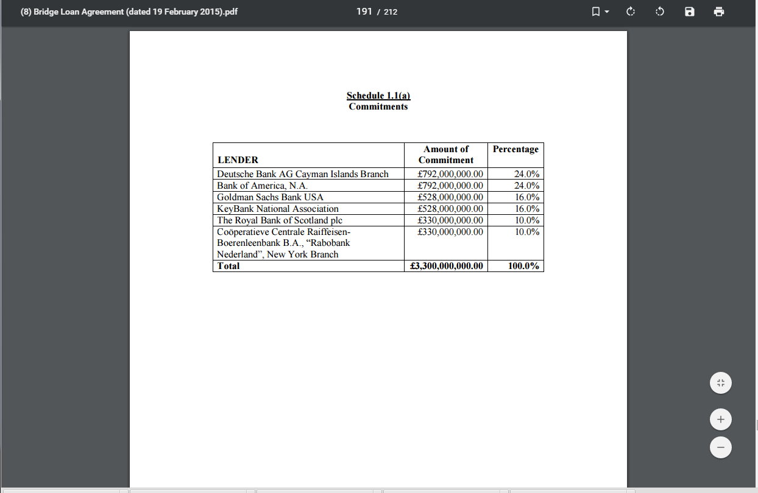

Lets look at some of the companies involved in the Satellite sector. You want to look for four Khazarian Rothschild companies that are majority shareholders. Vanguard Group, State Street Corp., Fidelity and Black Rock. Go toinvestors.morningstar.com and put in the ticker symbol. Look for Equity Ownership/Institutions and you’ll see the same entities in control. As you’ll see, the are plenty of publicly held companies and a bevy of privately held contractors whose majority stakeholders could quite possibly be the Khazarians.
Why do I say that? As it turns out the Rothschilds are into the Venture Capital game, for example The Edmond De Rothschild Investment Partners. They can capitalize startups and have a major equity stake in them while adding another pawn to their chessboard. Also khazarian alliances such as the Rothschild Investment Partners and Global Corporate Partners can be forged to gobble-up smaller companies as vassals. Here is a telling quote from the press release;
“Gerald Rosenfeld, Chief Executive Officer of Rothschild North America, said, “We believe the combination of Rothschild’s global relationships and Global Technology Partner’s access to and knowledge of the international defense and aerospace industry will create high level strategic advisory and investment opportunities. These opportunities will arise from the continued consolidation of second and third tier defense companies, the anticipated relationships that are forming among aerospace and defense companies on a cross border basis and GTP’s insight into defense markets and technologies.”
FYI, current Secretary Of Defense Ashton Carter is one of the original seven Global Technology Partners which pretty much sums it all-up. Read his corporate bio and realize he’s in bed with the Khazarians too. Below are a few examples of Satellite related companies that have Rothschild majority ownership.
Sample Of Satellite Majority Shareholders:
United Technologies, Intel Sat, DirecTV via ATT, Loral Space and Communications, Northrup Grumman, Raytheon, Ball Aerospace and Technology Corp., Lockheed Martin, General Electric
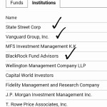
Don’t forget as in Part 1 the same institutional majority shareholders of major Hollywood companies and subsidiaries such as Disney, Comcast, MGM, Time Warner, Dreamworks, Sony Entertaiment are Khazarian owned. Again, go to invest.morningstar.com and look-up these companies. Look for Vanguard Group, Fidelity, BlackRock LLC and State Street Corp. as majority shareholders, and thus Hollywood andThe Controlled Major Mass Media become defacto propaganda machines for NASA. With the aquisition of Pixar by Disney in 2006 and Disney as a proven co-conspirator, we already have been subject to Pixar fakery as well.

